|  |  |
| --- | --- |
| Lịch sử FPT Aptech - FPT Aptech | **FPT ACADEMY INTERNATIONAL**  **FPT - APTECH COMPUTER EDUCATION** |

**Centre Name:** ACE-THUDUC-1-FPT

**Address:** 62 Street 36, Van Phuc Residential Area, Hiep Binh Phuoc Ward, Thu Duc City, Ho Chi Minh City, Viet Nam.

**PICNIC GAMES**

|  |  |  |
| --- | --- | --- |
| **Supervisor.** | Mr. Pham Cong Danh | |
| **Batch.** | T5.2310.E1 | |
| **Group.** | Group 4 | |
| **Serial No.** | **Enrollment Number** | **Student Name** |
| **1.** | Student1526148 | Tran Cong Tan |
| **2.** | Student1529017 | Nguyen Van Thuong |
| **3.** | Student1529020 | Nguyen Hoang Quan |
| **4.** | Student1529019 | Nguyen Thi Mai Huong |
| **5.** | Student1526180 | Le Thanh Dat |

**Mar-13-2024**

**This is to certify that**

**Mr/Mrs:**

Tran Cong Tan

Nguyen Van Thuong

Nguyen Hoang Quan

Nguyen Thi Mai Huong

Le Thanh Dat

**has successfully designed & developed**

eProject: PicnicGames

**Submitted by:**

Tran Cong Tan

**Date of issue: Mar-13-2024**

**Authorized Signature:**

Tan

**TABLE OF CONTENTS**

ACKNOWLEDGEMENT 2

SYNOPSIS 2

PROBLEM DEFINITION 2

CUSTOMER'S REQUIREMENTS SPECIFICATIONS (CRS) 4

HARDWARE / SOFTWARE REQUIREMENTS 6

SCOPE OF THE WORK (IN BRIEF) 7

ARCHITECTURE AND DESIGN OF THE SYSTEM 8

MAP OF THE WEBSITE 9

TASK SHEET REVIEW 1 10

SITE MAP 11

MOCK OF THE WEBSITE 12

1. Homepage 12

2. About Us 13

3. Games 14

4. Locations 15

5. News 16

6. Feedback 17

TASK SHEET REVIEW 2 18

UI DESIGN 19

1. Header & Navigation Bar 19

2. Footer 19

3. Homepage 19

3. About 22

4. Games 24

5. Details of Game 25

6. Contact Us 26

7. Gallery 27

TASK SHEET REVIEW 3 28

# ACKNOWLEDGEMENT

On behalf of myself, I would like to thank all members of group 4 for your hard work and contribution towards the completion of this eProject. I would also like to show my gratitude for Mr. Pham Cong Danh for his valuable assistance during both the planning and development phase. Finally, I would like to thank Aptech for allowing us the opportunity to hone our programming skills and test ourselves on real-life problems. Thank you!

# SYNOPSIS

Website PicnicGames is a unit specializing in providing indoor/outdoor games, picnic locations and picnic organization services for family and friends to help people become closer together. than in a bustling, bustling life

The website is to be developed for the Windows Platform using HTML5, JavaScript and Geolocation. The site should work well in all leading browsers including Chrome, IE, Firefox etc.

# PROBLEM DEFINITION

The Web site is to be created based on the following requirements.

1. The Home Page should be created making use of Sections with a suitable logo, the header section can be added which will show images of various creative products.

2. The site must contain the links to navigate through any category for the information.

3. The games should be categorized according to the type of games indoor/outdoor

4. Also there should different be sections for

- Kids

- Males

- Females

- Family games

5. When a user selects any particular category, a list of available game options for that particular category will be displayed

6. All details about the selected game to be displayed as material needed, time required, how to play etc with the demo videos / instruction document ,also these should be stored in Individual Word documents which can be downloaded or viewed by the User who wishes to see the same.

7. Along with the games there should also be a section for a common iternery for small getaways with suggested locations.

8. Site Makers Contact us page: contact us details with location should be displayed using GeoLocation API (eg. GoogleMaps).

9. Navigation should be smooth and images should be clear.

# CUSTOMER'S REQUIREMENTS SPECIFICATIONS (CRS)

Client: PicnicGames

**Business/Project Objective:**

The Objective of this program is to give a sample project to work on real life projects. These applications help you build a larger more robust application.

The objective is not to teach you HTML/JavaScript/Dreamweaver but to provide you with a real life scenario and help you create basic applications using the tools.

You can revise the chapters before you start with the project.

This project is meant for students who have completed the module of HTML5. These programs should be done in the Lab sessions with assistance of the faculty if required.

It is very essential that a student has a clear understanding of the subject. Students should go through the project and solve the assignments as per requirements given.

Kindly get back @ eprojects@aptech.ac.in in case of any doubts regarding the application or its objectives.

**Input to the system:**

- Browse games, picnic locations by category...

Output from the system:

- A menu that will categorize all the functions of the site.

- Display the list of available games, locations category wisely.

- Site should be able to provide brief introduction/history about the company under About Us page.

- The location of the company is in Contact Us page.

- Besides the above requirements, the site should have look and feel as per the industry standards.

**Expected delivery date:** Mar-13-2024

**List of deliverables:**

- Document Word.

- User Guide.

- Source code.

# HARDWARE / SOFTWARE REQUIREMENTS

**Hardware**

* A minimum computer system that will help you access all the tools in the courses is a Pentium 166 or better
* 64 Megabytes of RAM or better

**Software**

* Notepad/HTML editor
* Dreamweaver
* IE 5.0/ Netscape 6.0

# SCOPE OF THE WORK (IN BRIEF)

**I have discussed with my group and we agreed upon the website layout shown as below:**

1. **Home:** Provides an overview of outstanding games and picnic locations
2. **About Us:** Offer a concise introduction to the business, such as the company’s mission, values, and history, as well as information about the team or founders.
3. **Games:** Create a page dedicated to categories, a list of some featured games, a summary of the game's name and introduction, and a button to navigate to the game's detailed instructions page.
4. **Locations:** Provides a list of suitable outdoor picnic locations, sorted by state, with each location providing a brief description of name, address, high-resolution images, and available amenities. available in the surroundings of the location
5. **Contact Us:** Provide contact information and a form to leave contact information in need of support, with a map showing the location of the headquarters
6. **Feedback:** Contains a form to collect feedback from customers and visitors who experience the website or have used PicnicGames' services, and has a list of outstanding customer reviews to create trust for visitors.

# ARCHITECTURE AND DESIGN OF THE SYSTEM

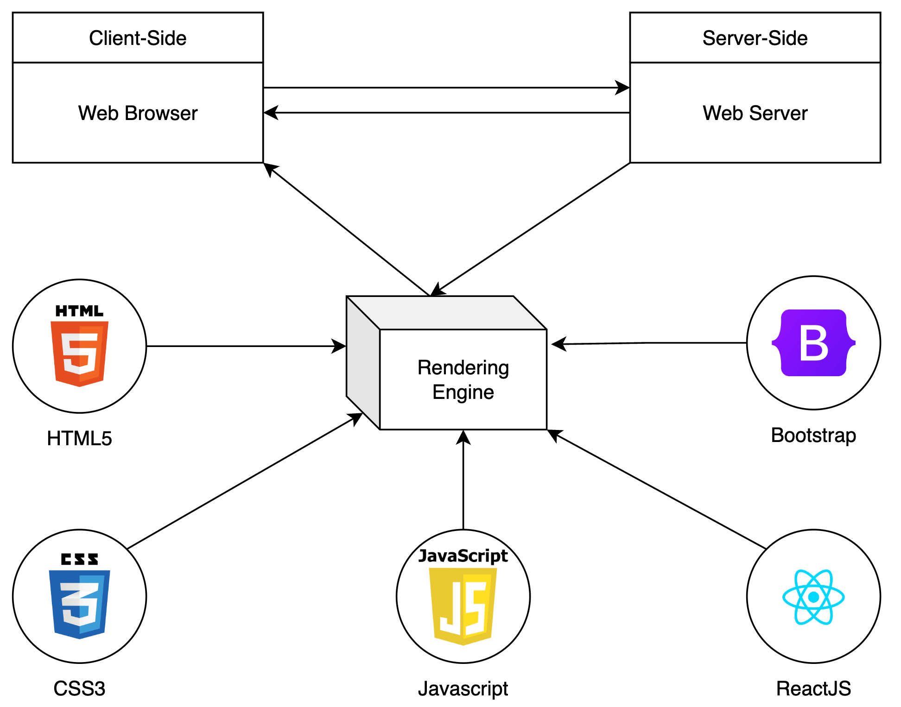

# MAP OF THE WEBSITE

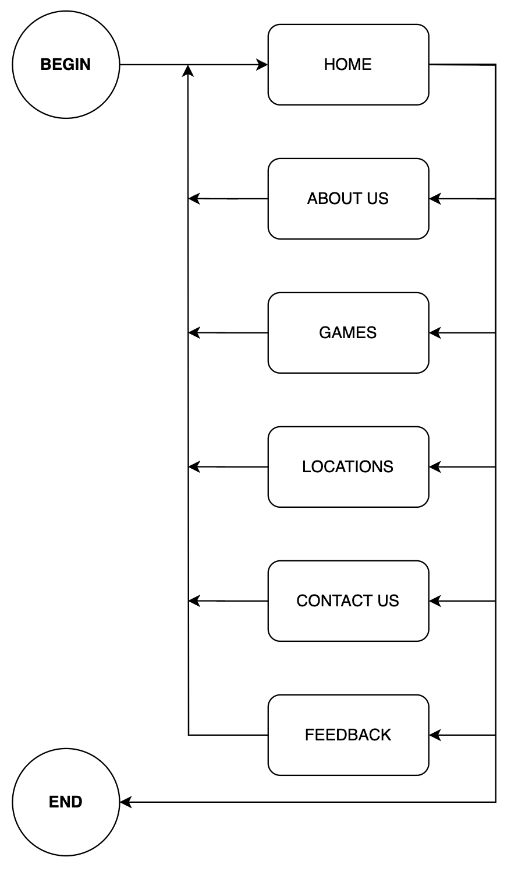

# TASK SHEET REVIEW 1

|  |  |  |  |  |  |  |  |
| --- | --- | --- | --- | --- | --- | --- | --- |
| **Project Ref. No.: eP/Advertisement Portal Management System/01** | | **Project Title:** | **Activity Plan Prepared By:** | **Date of Preparation of Activity Plan:** | | | |
| **Sr.**  **No.** | **Task** | **Actual Start Date** | **Actual Days** | **Team Mate Names** | **Status** |
| 1 | Problem Statement | PicnicGames | Tan | Jan-30-2024 | 1 | Tan, Thuong, Quan, Huong, Dat | Completed |
| 2 | Analysis of the requirements about the website | Jan-30-2024 | 1 | Tan, Thuong, Quan, Huong, Dat | Completed |
| 3 | The scope of the work (inbrief) | Jan-30-2024 | 1 | Tan, Thuong, Quan, Huong, Dat | Completed |
| 4 | Architecture and design of the system | Jan-30-2024 | 1 | Tan, Thuong, Quan, Huong, Dat | Completed |
| 5 | Diagram of the website | Jan-30-2024 | 1 | Tan, Thuong, Quan, Huong, Dat | Completed |
| 6 | Task sheet | Jan-30-2024 | 1 | Tan, Thuong, Quan, Huong, Dat | Completed |

|  |  |
| --- | --- |
| **Date: Feb-21-2024** | |
| Signature of Instructor:  **Mr. Pham Cong Danh** | Signature of Team Leader:  **Mr. Tran Cong Tan** |

# SITE MAP

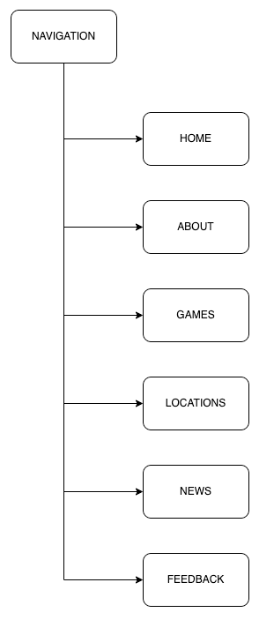

# MOCK OF THE WEBSITE

## 1. Homepage

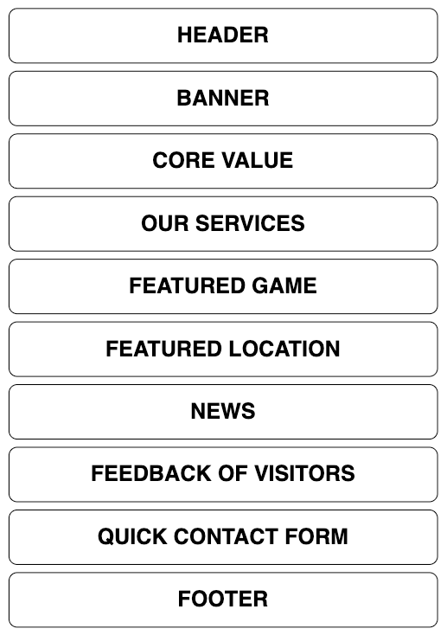

## 2. About Us

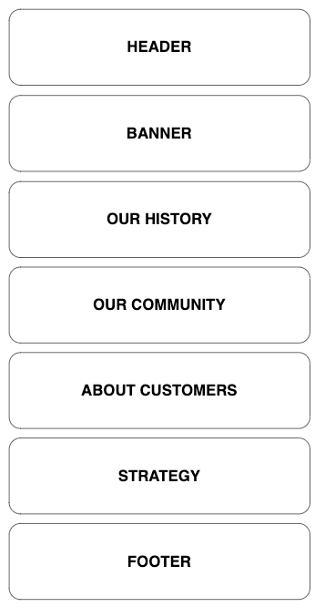

## 3. Games

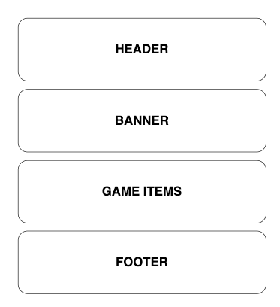

## 4. Locations

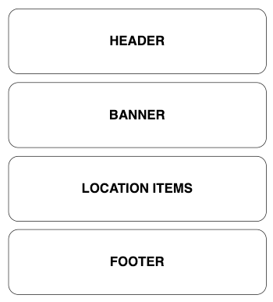

## 5. News

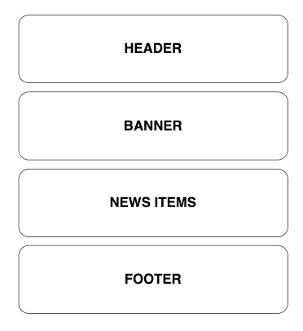

## 6. Feedback

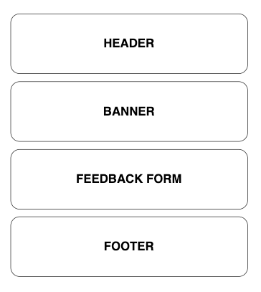

# TASK SHEET REVIEW 2

|  |  |  |  |  |  |  |  |
| --- | --- | --- | --- | --- | --- | --- | --- |
| **Project Ref. No.: eP/Advertisement Portal Management System/01** | | **Project Title:** | **Activity Plan Prepared By:** | **Date of Preparation of Activity Plan:** | | | |
| **Sr.**  **No.** | **Task** | **Actual Start Date** | **Actual Days** | **Team Mate Names** | **Status** |
| 1 | Site map | PicnicGames | Tan | Jan-30-2024 | 1 | Tan, Thuong, Quan, Huong, Dat | Completed |
| 2 | Mock of the website | Jan-30-2024 | 1 | Tan, Thuong, Quan, Huong, Dat | Completed |
| 3 | Task sheet | Jan-30-2024 | 1 | Tan, Thuong, Quan, Huong, Dat | Completed |

|  |  |
| --- | --- |
| **Date: Mar-2-2024** | |
| Signature of Instructor:  **Mr. Pham Cong Danh** | Signature of Team Leader:  **Mr. Tran Cong Tan** |

# UI DESIGN

## 1. Header & Navigation Bar



## 2. Footer

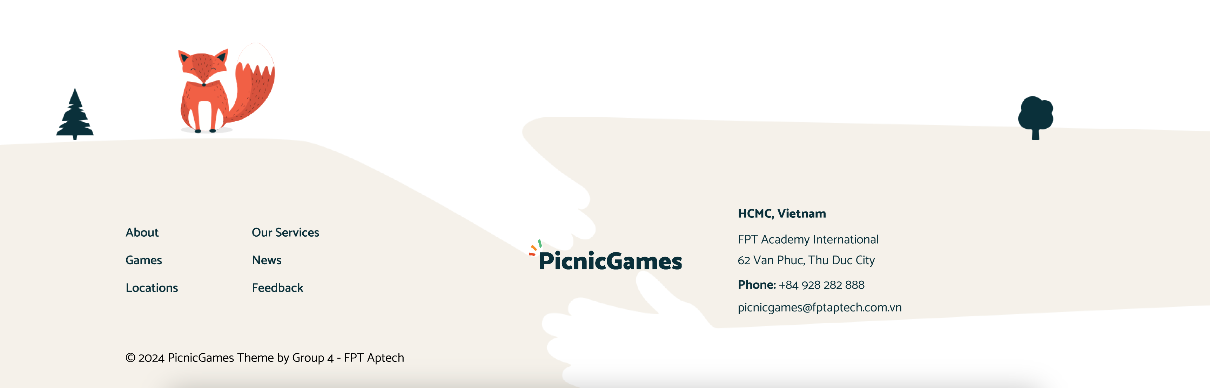

## 3. Homepage

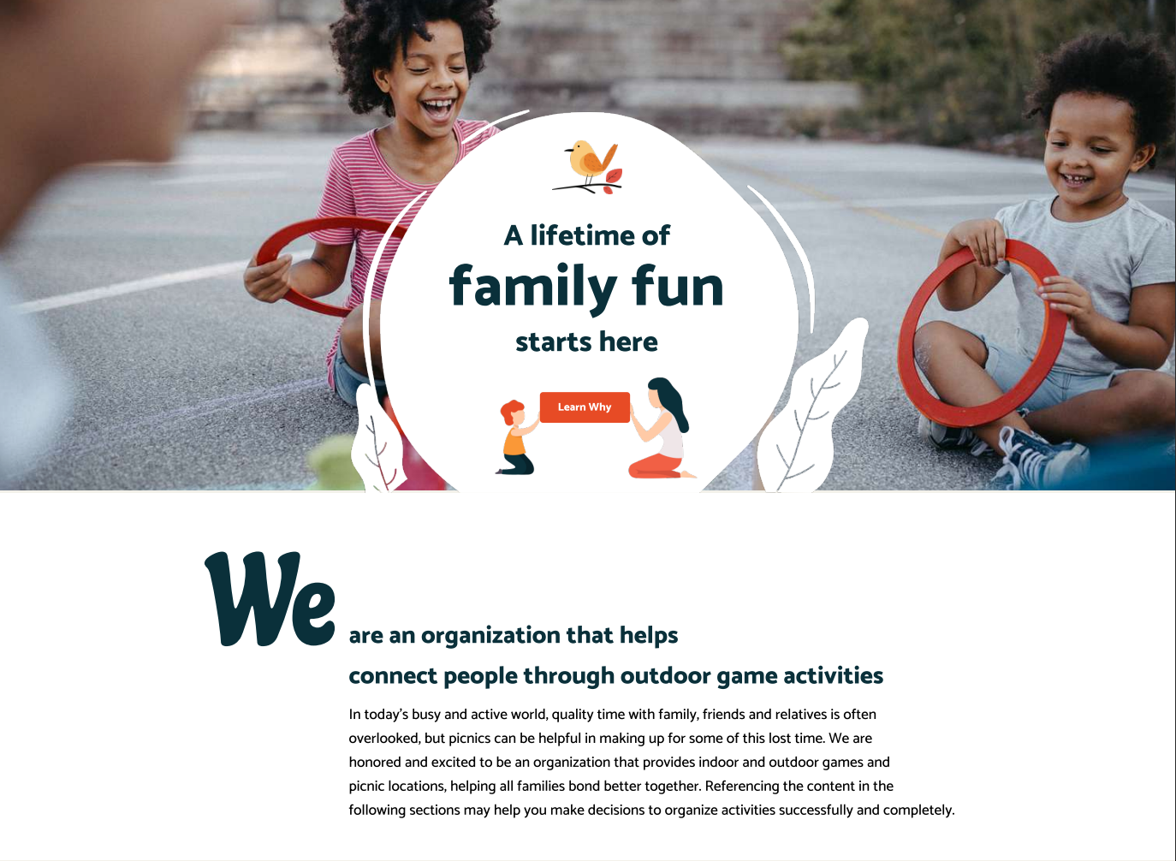

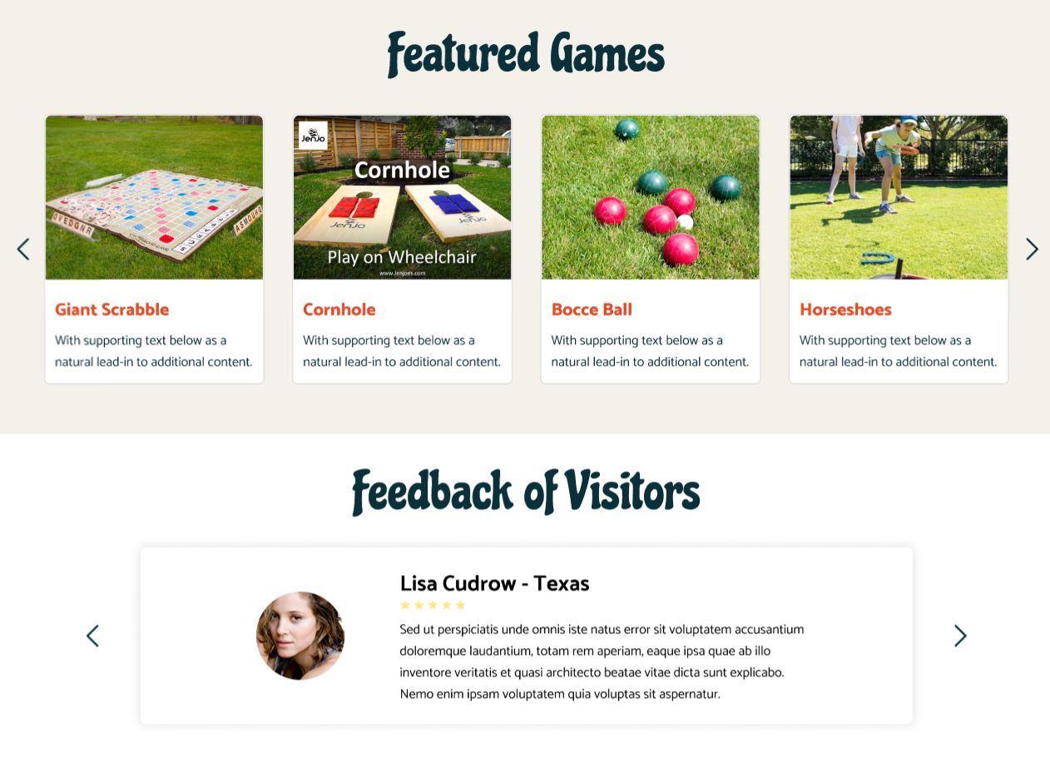



## 3. About

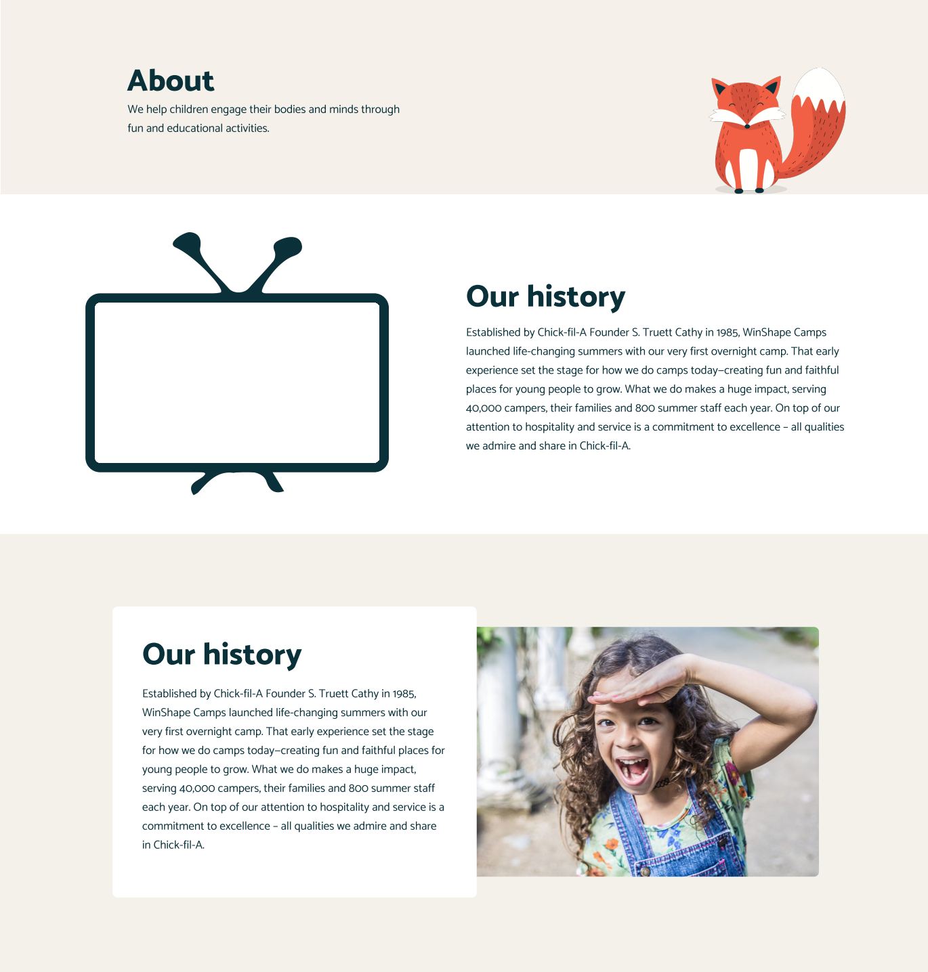



## 4. Games

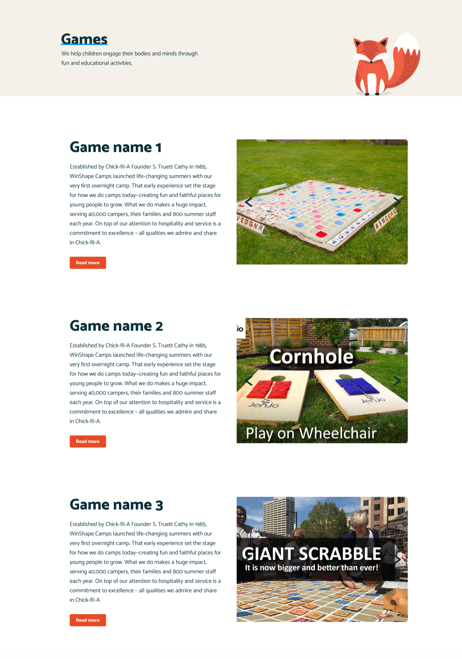

## 5. Details of Game

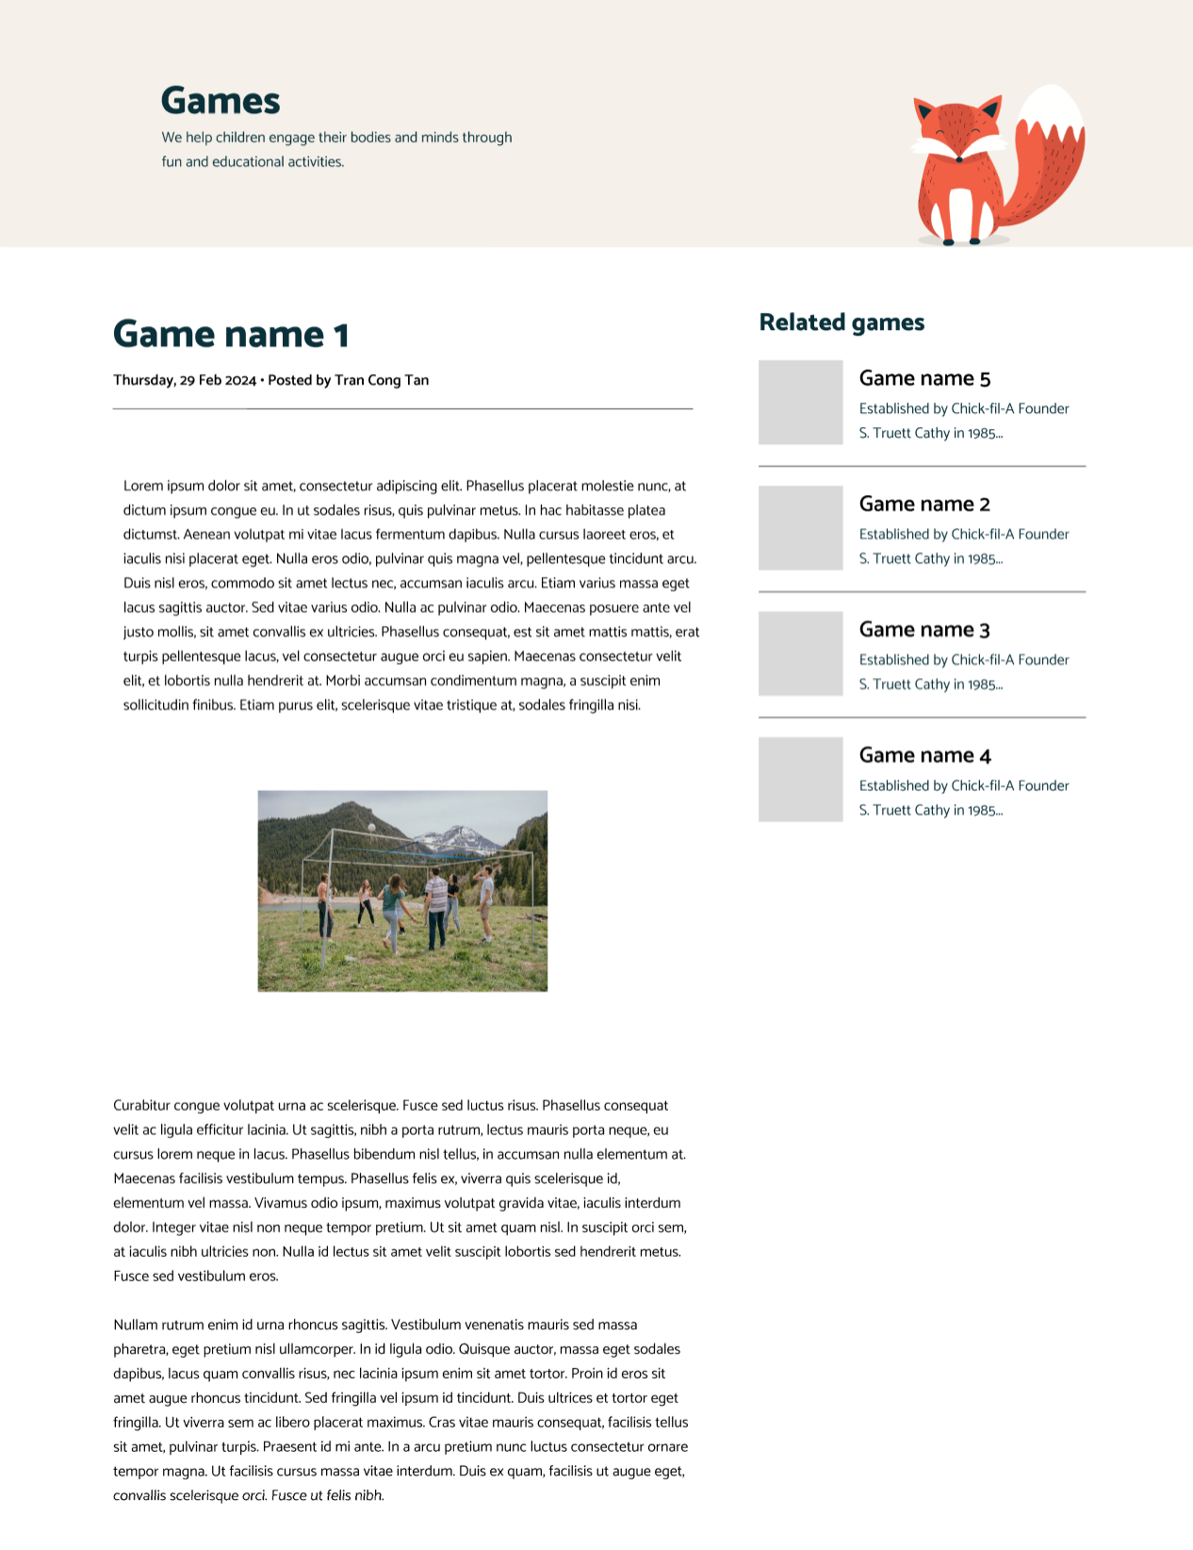

## 6. Contact Us



## 7. Gallery

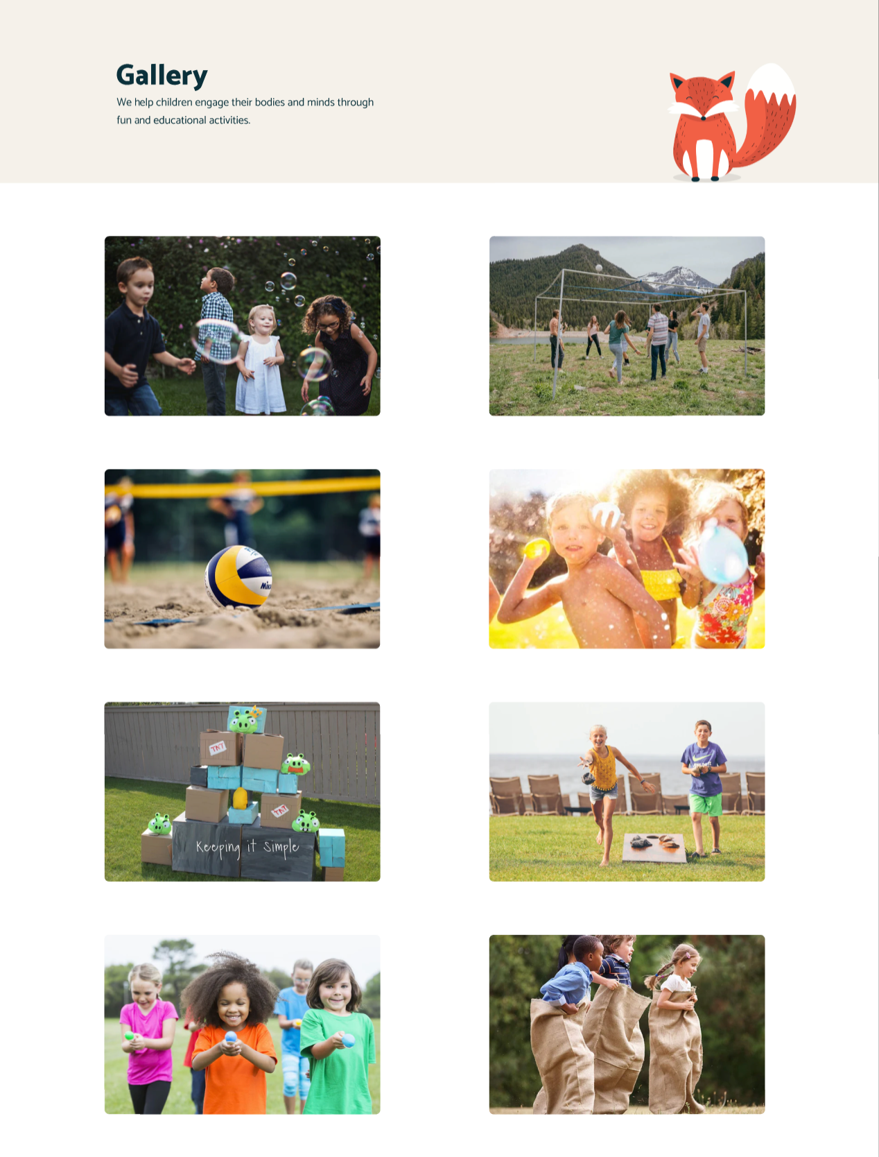

# TASK SHEET REVIEW 3

|  |  |  |  |  |  |  |  |
| --- | --- | --- | --- | --- | --- | --- | --- |
| **Project Ref. No.: eP/Advertisement Portal Management System/01** | | **Project Title:** | **Activity Plan Prepared By:** | **Date of Preparation of Activity Plan:** | | | |
| **Sr.**  **No.** | **Task** | **Actual Start Date** | **Actual Days** | **Team Mate Names** | **Status** |
| 1 | Header & Navigation Bar | PicnicGames | Tan | Mar-3-2024 | 1 | Tan, Thuong, Quan, Huong, Dat | Completed |
| 2 | Footer | Mar-3-2024 | 1 | Completed |
| 3 | Homepage | Mar-3-2024 | 1 | Completed |
| 4 | Games | Mar-3-2024 | 1 | Completed |
| 5 | Details of Game | Mar-3-2024 | 1 | Completed |
| 6 | Contact Us | Mar-3-2024 | 1 | Completed |
| 7 | Gallery | Mar-3-2024 | 1 | Completed |

|  |  |
| --- | --- |
| **Date: Mar-11-2024** | |
| Signature of Instructor:  **Mr. Pham Cong Danh** | Signature of Team Leader:  **Mr. Tran Cong Tan** |